Lesson 2 - The History of Set Design

This lesson introduces the history of set design from the early days of Greek theater to the processes used today by set designers around the world. Several innovations, and their innovators are named, and the different types of representational models and drawings used today are discussed.

Action Without Context
Imagine two people acting out a dramatic scene from a Shakespearian play in the middle of a parking lot. They are dressed in everyday clothing and anytime they use an object, it is an imaginary item. You might feel pretty confused about what is going on. This confusion directly relates to the lack of setting and set design. If this scene were transported to a stage, or if the actors wore costumes and held real props, or even if a few set backgrounds helped indicate the imaginary places the action occurred, you, and others watching the strange sight might have a better idea of what is going on. This highlights the importance of set design, but let's look deeper into what a set designer does, how they do it, and a little history of set design itself.
Question: Explain the importance of set design?
_______________________________________________________________________________________________________________________________________________________________________________________________________________________________________________________________

History of Set Design
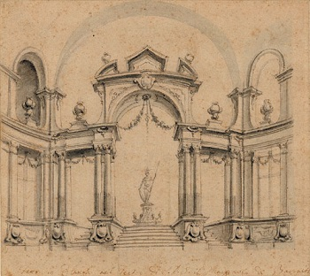
Set design sketch c. 1750
While acting and theater have always existed in some form, the origins of theater as we know it and the introduction of sets comes to us from ancient Greece. This is where storytelling and ritual practices of acting out sacred stories combined to entertain audiences, with a variety of stories performed on stages with actors demonstrating the plots. Originally, these plays involved only one or two actors, but over time they added a full cast, complex plots, and varying locations. To prevent audiences from getting confused, they needed a way to signal the different locations of the action and easily tell the actors apart. Thus, set design was born in Greek theater, and used early on its Roman counterpart as well.
While these early sets used only a few painted backdrops, the Italian Renaissance brought life to set design using the development of perspective painting to create depth and different elevations for the action on stage. During the Baroque period, Giacomo Torelli developed changeable scenery using chariots, ropes, and pulleys which allowed more complex settings. The 19th century interest in realism spurred further development in set design with the introduction of assorted props in each set, and the creation of box sets, three-sides sets meant to simulate interior rooms with entrances and exits. Finally, in the 20th century, famous set designer Adolf Appia created a new standard of set design using representational props to symbolize a fully stocked set without overcrowding the stage. Today, Appia's detailed, symbolic method with computer-generated projections adds a realism to sets while maintaining audiences' focus on the actors.
Questions:
Question 1: Where did set design originate?____________________________________________
Question 2: How many sides does a Box Set have?_____________________________________
Question 3: Wow is realism achieved?___________________________________________________
Question 4: Who designed changeable set design?__________________________________________

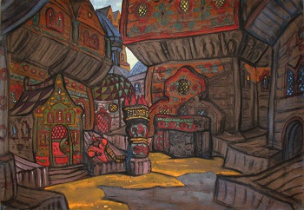
Set Design by Nicholas Roerich for the 1909 Russian Ballet performance of Polovtsian Dances

What Do Set Designers Do Today?
The set designer begins with the script, examining the details to identify various locations, necessary props, and any actions that require specially built sets. Additionally, the set designer gets a feel for the time period, what visual elements convey the best sense of the play, and other aspects needed to give audiences the full illusion of real characters in real places. Next, the set designer meets with the director and other key design professionals to collaborate on the director's vision for the show, what equipment will be available, and what skills the others provide. From this first meeting, the set designer creates thumbnails, preliminary sketches of the set design, which will be refined by further collaborative meetings.

Questions
Question 1: Outline the process of set design? ___________________________________________________________________________________________________________________________________________________________________________________________________________________________________________________________________________________________________________________________________________________
